FRID chips to put in each card would cost 28p each meaning a full deck would be £14.56 to fit with chips.

**RFID tags** contain an integrated circuit and an antenna, which are used to transmit data to the **RFID** reader (also called an interrogator). The reader then converts the radio waves to a more usable form of data.

Unlike a [barcode](https://en.wikipedia.org/wiki/Barcode), the tag does not need to be within the line of sight of the reader, so it may be embedded in the tracked object.

RFID tags are used in many industries. For example, an RFID tag attached to an automobile during production can be used to track its progress through the assembly line, RFID-tagged pharmaceuticals can be tracked through warehouses, and [implanting RFID microchips](https://en.wikipedia.org/wiki/Microchip_implant_(animal)) in livestock and pets enables positive identification of animals.

Price of FRID chips

<https://seritag.com/nfc-tags/midas-clear-ntag213?vat=true&gclid=CjwKCAiA4rGCBhAQEiwAelVtiyyiTxgxNt3pYq2pfdqsL0vHDXXNah81nFD1jFd5yRMeJ0bwgj56TBoCoFcQAvD_BwE>

NTAG 213/216F

A high frequency FRID chip commonly used in games perfect for our cards

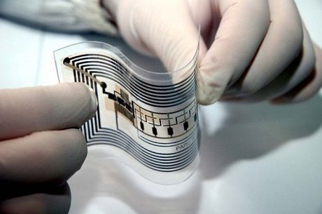<https://www.asiarfid.com/about-rfid-chips.html>

<https://www.google.com/search?q=rfid+chips+in+playing+cards&rlz=1C1CHZL_en-GBGB917GB917&sxsrf=ALeKk00DEeOfcvsJ-SFgS3jNBRKEfQJY9w:1617013918752&source=lnms&tbm=isch&sa=X&ved=2ahUKEwiZh-WhptXvAhULecAKHf1tBukQ_AUoAnoECAEQBA&biw=1920&bih=937#imgrc=WkCNq1estyk2bM&imgdii=MqNrcDe8sT7eUM>

<https://www.google.com/search?q=rfid+chips+in+playing+cards&rlz=1C1CHZL_en-GBGB917GB917&sxsrf=ALeKk00DEeOfcvsJ-SFgS3jNBRKEfQJY9w:1617013918752&source=lnms&tbm=isch&sa=X&ved=2ahUKEwiZh-WhptXvAhULecAKHf1tBukQ_AUoAnoECAEQBA&biw=1920&bih=937#imgrc=La7TPUiaym19ZM>